A Mini Project Report on
CryptoVest
(Crypto Currency and Stock Market analysis)

T.E. - I.T Engineering

Submitted By
Nishank Jain 20104
Jaykumar Nayi 20104005
Anish Bhosle 20104033

Under The Guidance Of
Prof. Roshna Sangle



DEPARTMENT OF INFORMATION TECHNOLOGY
A.P.SHAH INSTITUTE OF TECHNOLOGY
G.B. Road, Kasarvadavali, Thane (W), Mumbai-400615
UNIVERSITY OF MUMBAI

Academic year : 2022-23

CERTIFICATE

This to certify that the Mini Project report on CryptoVest has been submitted by _______201040________(Student ID), ______20104005_________ (Student ID) and __________20104033______(Student ID) who are a Bonafede students of A. P. Shah Institute of Technology, Thane, Mumbai, as a partial fulfilment of the requirement for the degree in Information Technology, during the academic year 2022-23 in the satisfactory manner as per the curriculum laid down by University of Mumbai.

Prof. Roshna Sangle
Guide

Prof. Kiran Deshpande Dr. Uttam D.Kolekar
Head Department of Information Technology Principal

External Examiner(s)
1.
2.

Place: A.P.Shah Institute of Technology, Thane
Date:

ACKNOWLEDGEMENT

This project would not have come to fruition without the invaluable help of our guide Prof. Roshna Sangle. Expressing gratitude towards our HOD, Prof. Kiran Deshpande, and the Department of Information Technology for providing us with the opportunity as well as the support required to pursue this project. We would also like to thank our teacher Ms. Yaminee Patil who gave us her valuable suggestions and ideas when we were in need of them. We would also like to thank our peers for their helpful suggestions.

ABSTRACT

Cryptocurrencies like Bitcoin have matured from being associated exclusively with techies and radicals to being considered by central banks as a technology to implement digital money. Cryptocurrencies exist only in digital form and can be transferred completely between digital addresses. This is both unlike conventional electronic money as understood by laypersons which acts as a debt claim on a deposit with a trusted financial institution such as a private bank and unlike conventional corporeal money which may be physically possessed. This means that any legal rights associated with holding cryptocurrencies must be different despite it being remaining open to interpretation. In this chapter, we look at the various treatments of money in the legal sense and discuss the risks associated with each by drawing on real life examples. We conclude that fraud through hacking could potentially pose a problem to widespread adoption of cryptocurrencies as the absence of recourse against a third party such as a bank concentrates risk in holders of cryptocurrencies. Users should thus exercise caution and understand the risks before investing in cryptocurrencies. This warning requires emphasis as many parties misapprehend the cryptography within the technology as protecting them from such fraud when in fact it does no such thing.

TABLE OF CONTENTS
- Introduction……………………………………………………………………..1
  - Purpose..................................................................................................... 1
  - Problem Statement………………………………………………………2
  - Objectives................................................................................................. 2
  - Scope........................................................................................................ 3
- Literature Review………………………………………………………………...4
- Proposed System……….........................................................................................7
  - Features and Functionality………………………………………………7
- Requirements Analysis......................................................................................... 9
- Project Design.......................................................................................................10
  - Use Case diagram……………………………………………………… 10
  - DFD (Data Flow Diagram) ……………………………………………..11
  - System Architecture……………………………………………………..12
- Technical specification……………...…………………………………………...13
- Project Scheduling.................................................................................................15
- Implementation…………………………………………………………………..16
9. Result and Discussion…………………………………………………………….17
- Conclusion and Future Scope.................................................................................18
References

Chapter 1
Introduction:
Establishing a definition of cryptocurrencies is no easy task. Much like blockchain, cryptocurrencies has become a “buzzword” to refer to a wide array of technological developments that utilise a technique better known as cryptography. In simple terms, cryptography is the technique of protecting information by transforming it (i.e. encrypting it) into an unreadable format that can only be deciphered (or decrypted) by someone who possesses a secret key.48 Cryptocurrencies such as Bitcoin, are secured via this technique using an ingenious system of public and private digital keys. 49 Hereinafter we try to give a suitable definition of cryptocurrencies on the basis of a critical analysis of the definitions already developed by various concerned policy makers at European and international level
Moreover, there is the possibility that crypto will be floated on the Nasdaq, which would further add credibility to cryptocurrency and its uses as an alternative to conventional currencies. This section is an explanation of the concepts and theories about Cryptocurrency and blockchain which have several implementations that have been applied.
The paper explores many aspects of Cryptocurrency platforms attempting to answer the main questions of this research which are “Will Cryptocurrency be the next currency platform? Are virtual currency platforms safe enough to be used?” It investigates different Cryptocurrency platforms in order to provide deep insight about mechanisms of implementing, controlling, issuing, spending and exchanging Cryptocurrencies which provides a useful and an organized CC classification. The paper also analyses current Cryptocurrency systems and platforms in order to extract concerns, problems, issues and challenges that are exist. It analyses the correlation between the real world laws and the use of CC aiming to outline the strong impacts of Cryptocurrency concept on some of real world aspects such as real monetary systems, business industry, laws breaking rates and crime payment methods. The outcomes draw the attention of all parties who participate in and affected by Cryptocurrency platforms to the importance of controlling Cryptocurrency use. Those parties are governments, operators and users. The outcomes also alert lawmakers and virtual currency providers to release and set up strict rules, policies and legislations to control virtual currency systems. Additionally, this paper provides a scientific content that create opportunities for further research.
1.1.Purpose :
It's a peer-to-peer system that can enable anyone anywhere to send and receive payments. Instead of being physical money carried around and exchanged in the real world, cryptocurrency payments exist purely as digital entries to an online database describing specific transactions.
1.1.1 Enhance Business Processes: Virtual currency offers a great opportunities for companies and operators to monetize their applications and then increase their revenues. There are many types of Cryptocurrency that are implemented in different platforms including Cryptocurrency in social networks, Cryptocurrency in social games, loyalty points and Cryptocurrency in peer to peer networks. These platforms can be classified into two main categories, centralized cryptocurrency platforms and decentralized cryptocurrency platforms.
1.2.Problem Statement :
The form of cryptocurrencies is not free from some financial problems and security concerns. We analyzed several studies and cryptocurrency platforms and also observed some cryptocurrency selling forums in order to explore challenges and issues that are exist in such virtual phenomenon.
1.3.Objectives :
The objective of cryptocurrency is to remove all the issues that come with traditional banking. There are no limits to the money you can transfer using bitcoin, accounts are almost impossible to hack because you are not using a financial institution , and there isn't a central point of failure.
Specific goals are -
- Protection from inflation –
Inflation has caused many currencies to get their value declined with time. Almost every cryptocurrency, at the time of its launch, is released with a fixed amount. The source code specifies the amount of any coin; like, there are only 21 million Bitcoins released in the world. So, as the demand increases, its value will increase which will keep up with the market and, in the long run, prevent inflation.
- Self-governed and managed –
Governance and maintenance of any currency is a major factor for its development. The cryptocurrency transactions are stored by developers/miners on their hardware, and they get the transaction fee as a reward for doing so. Since the miners are getting paid for it, they keep transaction records accurate and up-to-date, keeping the integrity of the cryptocurrency and the records decentralized.
- Secure and private –
Privacy and security have always been a major concern for cryptocurrencies. The blockchain ledger is based on different mathematical puzzles, which are hard to decode. This makes a cryptocurrency more secure than ordinary electronic transactions. Cryptocurrencies, for better security and privacy, use pseudonyms that are unconnected to any user, account or stored data that could be linked to a profile.
- Currency exchanges can be done easily –
Cryptocurrency can be bought using many currencies like the US dollar, European euro, British pound, Indian rupee or Japanese yen. With the help of different cryptocurrency wallets and exchanges, one currency can be converted into the other by trading in cryptocurrency, across different wallets, and with minimal transaction fees.
- Decentralized –
A major pro of cryptocurrency is that they are mainly decentralized. A lot of cryptocurrencies are controlled by the developers using it and the people who have a significant amount of the coin, or by an organization to develop it before it is released into the market. The decentralization helps keep the currency monopoly free and in check so that no one organization can determine the flow and the value of the coin, which, in turn, will keep it stable and secure, unlike fiat currencies which are controlled by the government.
- Cost-effective mode of transaction –
One of the major uses of cryptocurrencies is to send money across borders. With the help of cryptocurrency, the transaction fees paid by a user is reduced to a negligible or zero amount. It does so by eliminating the need for third parties, like VISA or PayPal, to verify a transaction. This removes the need to pay any extra transaction fees.
- A fast way to transfer funds –
Cryptocurrencies have always kept itself as an optimal solution for transactions. Transactions, whether international or domestic in cryptocurrencies, are lightning-fast. This is because the verification requires very little time to process as there are very few barriers to cross.

1.4.Scope :
There are over 4000 cryptocurrencies as of early 2021 but it is believed that top 20 cryptocurrencies hold the market share upto 90%. [1] Earlier people used to invest in gold as an asset to protect their money against inflation. Over the past couple of years, more people found Bitcoin to be a better alternative asset.
Analysts estimate that the global cryptocurrency market will more than triple by 2030, hitting a valuation of nearly $5 billion. Whether they want to buy into it or not, investors, businesses, and brands can't ignore the rising tide of crypto for long.
There is no need of middleman. All the transactions are done on one to one basis and it also becomes easier to establish audit trials.
These currencies can overcome the problem of social trust and by increasing its access, it can serve to increase the growth process in developing countries.
Unlike other traditional payment systems like debit and credit card, crypto currencies have no processing charge, since those transactions are facilitated through crypto currency’s public network which is called Blockchain technology.
Credit or debit cards often take two or three days to process. With crypto currencies, transactions take 10 minutes to clear it. This shows that the speed of transactions in case of crypto currencies is high.

Chapter 2
Literature Review :
According to Trautman (2014), cryptocurrencies are a subset of digital currencies that may have either centralized institutions or are based on a decentralized network. In simple terms, cryptocurrencies are a new type of currency (Duque, 2020; Hudson & Urquhart, 2019) that is digital and produced from cryptographic algorithms, exchanged across the Internet using protocols such as peer-to-peer networking (Nakamoto, 2008). Another way to define cryptocurrencies is the fact that they are based on the use of complex cryptographic techniques to provide users with a secure and safe medium of exchange (Bulut, 2018). The creation of value (or money) and the triggering of transactions are governed by the mining process, which is a set of mathematical algorithms that are implemented within the underlying protocol (Adhami et al., 2018; Cennamo et al., 2020). Most cryptocurrencies are created to introduce new units of currency with a limited total amount (Baur et al., 2015). Unlike state-issued currencies, cryptocurrencies are not governed by established laws, but by technology (Dodd, 2018). Accordingly, this makes cryptocurrencies a new invention that is different from traditional currencies. In the field of finance, the advent of cryptocurrencies represents a new area that requires additional public and academic attention (Aslan & Sensoy, 2020; Baumöhl, 2019; Cerqueti et al., 2020; Corbet et al., 2019; Platanakis et al., 2018; Vidal-Tomás et al., 2019). At the time of writing, the cryptocurrencies market was valued at approximately USD 300 billion, with nearly 80% of that value in Bitcoin tokens. The landscape for cryptocurrencies has grown exponentially over the years (Babkin et al., 2017; Dimitrova et al., 2019). From a technical perspective, cryptocurrencies work through a peer-topeer, distributed, and decentralized network (Nakamoto, 2008). That said, there are no specific regulatory bodies (Alonso & Luis, 2019; Ng & Griffin, 2018; Yalaman & Yıldırım, 2019) that verify and control the transactions and the transfer of value within the network. Second, cryptocurrencies operate within a robust, unhackable peer-to-peer infrastructure underpinned by blockchain technology (Clark & Burstall, 2018; Karpan, 2019; J. Wang et al., 2017). The technology helps to guarantee that financial transactions and value transfers between two parties, regardless of their type, are carried out directly and without the intermediation of a third party (Keogh, Dube, et al., 2020; Keogh, Rejeb, et al., 2020; Treiblmaier, 2019). In finance applications, the power of blockchain technology lies in its ability to solve the double-spending problem (Treiblmaier, 2019). This is the likelihood that the same digital token can be spent more than once because a digital token consists of a digital file that can be duplicated or falsified (Chohan, 2017). Cryptocurrencies use the public Internet, which provides speed, resiliency and efficiency (G. Wang, 2019). The absence of trust between the exchange partners is empowered by public-key cryptography mechanisms used to secure the conclusions of money transactions (Korpela et al., 2017; Rowan et al., 2017; Uddin et al., 2019).
In this section is an explanation of the concepts and theories about Cryptocurrency and blockchain which have several implementations that have been applied. The adoption and acceptance level of cryptocurrency has increased and can be recognized by the following indicators market capitalization, estimated number of users, and transaction volume. The cryptocurrency market value reached its peak at the e. The cryptocurrency market value reached its peak at the end of 2017 with more than $800B. However, the high volatility of the price influence the market capitalization dramatically.
More recently, there are about 16.523 million units of bitcoin in circulation, which means that 79% of bitcoin has already been mined (Wilson, 2019). The limit of the number of bitcoins being minted (i.e., mined) helps ensure a stable supply of this cryptocurrency as no individual, financial institution, or government has the power to control the supply of bitcoins or to inflate their value. Every unit of cryptocurrency has its own address with the public and private key. Transactions are triggered using the private key. At any point in time, there is a fixed number of cryptocurrencies, and the blockchain enables a network user to prove ownership of a particular cryptocurrency and to verifiably transfer ownership without the recourse to a third party (Brito et al., 2015). In the cryptocurrency financial system, users can gain value by engaging in particular transactions with other users (e.g., sale of products) or by mining (Courtois et al., 2014; Hayes, 2015; Lim et al., 2014). The latter is the process of recording several transactions as a block in the blockchain (Conti et al., 2018). Miners are specialized nodes (i.e., computers) that pick up transaction records, verify them and create new blocks by performing complex computing operations and cryptographic functions. In the example of bitcoin, miners solve the mining puzzle (Houy, 2014) in approximately ten minutes and receive bitcoin rewards in return.
As previously stated, the use of blockchain technology in leveraging cryptocurrencies can mitigate the cost of trust (Berg et al., 2019), which is an essential element that manifests itself in various ways in the financial system. These costs include the intermediary’s commissions, the fees of entering and upholding contracts, settlement procedures, cybersecurity, and user authentication. Money depositors must trust banks to secure their savings (Baldwin, 2018; Maurer et al., 2013; Raymaekers, 2015; Zook & Blankenship, 2018).
The financial sector has multiple challenges and experienced recent crises. For example, millions of people around the world lost their jobs and homes as a consequence of the 2008 global financial crisis. Although cryptocurrencies are not a panacea for all financial problems, it is still important to explore how these economic and financial instruments can impact financial stability and establish a more resilient financial sector. It is widely argued that centralized financial institutions concentrate risks, socialize losses and collect significant economic rents (Zhang, 2017). Cryptocurrencies can address several issues inherited in the current financial systems, such as the lack of trust, transaction inefficiencies, and instability (Nakamoto, 2008).

Chapter 3
Proposed System :
This system will allow a car rental company to accept rentals by advance reservation; the company will also accept customers who walk in to hire a car if it is available. At the end of each day, returned cars are assigned to the reservations for the following day. If more cars are requested than available cars at any of the outlets, the branch manager may ask for extra cars from other outlets.
Cars rented from of the organization's outlet may be returned to any other outlet. The renting outlet must ensure that cars are returned as per the pick-up and return dates indicated as per the car rental contract. Whenever a car is returned to a different outlet other than the renting outlet, the new outlet is assigned ownership.
Only one booking is allowed per day but the customer may make reservations of different cars for future use. There is an exception when a customer is reserving for an event. During this case, the customer must provide details of at least one person who will be responsible for each car. Customers are allowed to give feedback about their experiences. On the other hand, the organization keeps a record of all rental and had experiences such late return, damaged cars, or payment problems. This information informs the decision of renting a car to customers in the future.
3.1. Features and Functionality :
Car Rental System provides the features for booking a car online. It includes several functionalities describes as below:
3.1.1 Car Rental Management:
It provides car reservation facility online. Customer can visit the website and check for various cars. If they are feasible with requirement, then booking can be done.
3.1.2 Checking For Availability:
Employee can check for the availability of the car. He/she maintains the database of car. If no any car is available it is the responsibility of the employee to provide alternative options.
3.1.3 Payment system :
Administrator/owner of the applications responsible for payment to the employee. Order cancellation, order finalize, these all activities are done by the administrator of the application.

Chapter 4
Requirements Analysis :
Requirement analysis is a software engineering technique that is composed of the various tasks that determine the needs or conditions that are to be met for a new or altered product, taking into consideration the possible conflicting requirements of the various users.
Functional requirements are those requirements that are used to illustrate the internal working nature of the system, the description of the system, and explanation of each subsystem. It consists of what task the system should perform, the processes involved, which data should the system holds and the interfaces with the user. The functional requirements identified are:
a. Customer’s registration: The system should allow new users to register online and generate membership card.
b. Online reservation of cars: Customers should be able to use the system to make booking and online reservation.
c. Automatic update to database once reservation is made or new customer registered: Whenever there’s new reservation or new registration, the system should be able update the database without any additional efforts from the admin.
d. Feedbacks to customers: It should provide means for customers to leave feedback.

Chapter 5
Project Design :
5.1.Use Case diagram
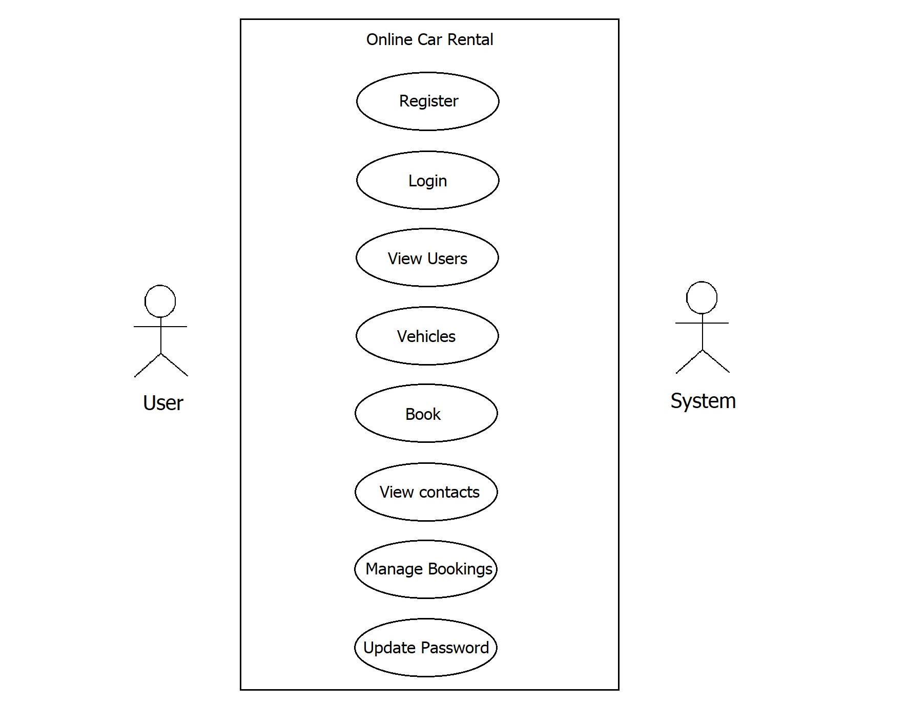
5.2.DFD (Data Flow Diagram)
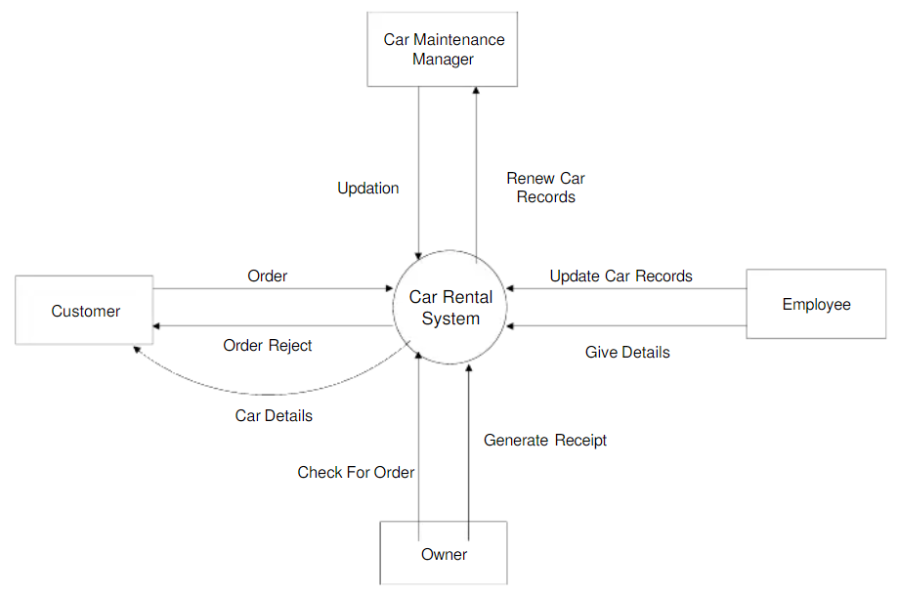
5.3.System Architecture
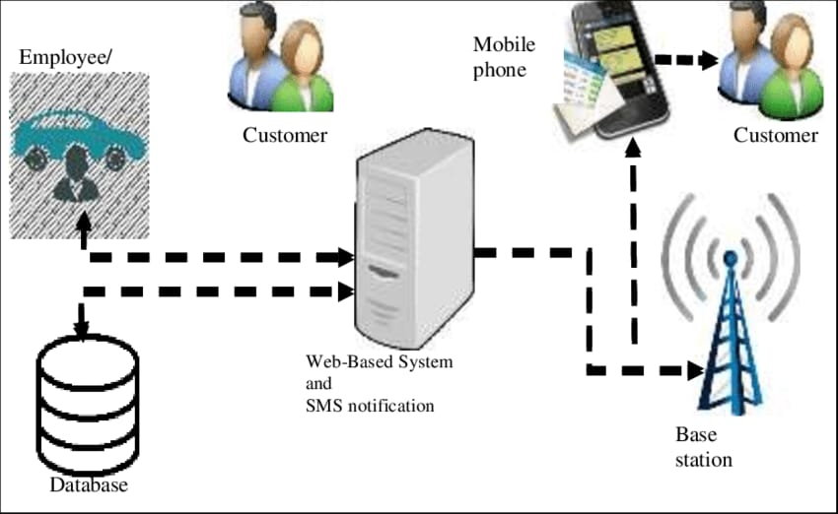
Chapter 6
Technical specification :

Chapter 7
Project Scheduling :

Chapter 8
Implementation :
Chapter 9
Result and Discussion :

Chapter 10
Conclusion and Future Scope :
Car rental business has emerged with a new goodies compared to the past experience where every activity concerning car rental business is limited to a physical location only. Even though the physical location has not been totally eradicated; the nature of functions and how these functions are achieved has been reshaped by the power of internet. Nowadays, customers can reserve cars online, rent car online, and have the car brought to their door step once the customer is a registered member or go to the office to pick the car. The web based car rental system has offered an advantage to both customers as well as Car Rental Company to efficiently and effectively manage the business and satisfies customers' need at the click of a button.
While several players have already entered and established themselves in the market, there is still scope for others. Every company is trying to provide better services and offers to get more reservations and this is bringing improvement and use of new automated technologies in the market. Now rental companies are focusing on customer support, training, sales, and marketing to stand out clearly and to communicate better with the customers. This will increase the customer footfall and sales. Most car rental businesses are doing good and some of them are working hard on every facet to improve their services. We can expect a bright future for all car rentals that are implementing smart tricks and technologies to stand out in the market.
References :

